**Atlas Lab**

**Report Employees Structure and Attrition   
- HR Analytics -**

Department of Analytics

Eliseu Silva de Abreu

Table of Contents

Introduction 3

Total Employees 3

Hiring Trends 3

Active Employees by Department 4

Active Employees by Department and Job Role 6

Age Range 6

Marital Status 7

Gender Identity by Age Group 8

Ethnicity Distribution and Average Salary 9

Overtime Requirement and Ternure 10

Attrition % by Department and Role 11

Attrition % by Travel Frequency 11

Conclusion 12

# 

# Introduction

In response to the growing need for comprehensive insights into workforce demographics and performance within organizations, the Analytics Department has developed a detailed report analyzing the employee structure of the fictional company, Atlas Lab. This report addresses key aspects such as age distribution within the company, ethnic composition, salary distribution, and the number of employees across various departments. Additionally, it provides an in-depth view of attrition rates segmented by department and individual employees, along with a performance tracker that evaluates employee and manager performance ratings from the last four years, as well as their satisfaction survey with a wide range of different areas in their lives.

This report aims to support HR and management teams by offering actionable data that can inform strategic decisions, improve retention strategies, and foster an equitable and performance-driven workplace environment. The insights derived from these analyses are designed to align with real-world organizational challenges, providing a foundation for more informed and data-centric HR practices.

Overview

This section focuses on providing a basic understanding of the employees and department structure of the company, offering an overview of key demographic and operational metrics. It includes detailed analyses of average age, ethnic composition, and salary distribution by ethnicity, as well as a breakdown of the number of employees in each department. This overview serves as a baseline for understanding the composition of the workforce and identifying potential areas for strategic improvement in talent management and departmental resource allocation.

## Total Employees

Atlas Lab has had a total of 1.470 employees, from 2012 to 2022. From this total, 1.233 are still in the company in 2022, while 237 have left, producing an Attrition Rate of 16,1%.

## Hiring Trends

There are three main trends that can be observed on the total number of hirings:

1. **2012 – 2017:** Atlas Lab experienced a steady decline in new employee hires, reducing the number by 30%, from 127 to 90. Despite this significant decrease in recruitment, the number of employees leaving the company remained relatively stable at around 24 annually, with only minor fluctuation
2. **2018 – 2019:** the company saw a shift in its hiring strategy, increasing recruitment numbers to nearly match 2012 levels, with 124 new hires recorded in 2019. This period also experienced a slight reduction in attrition rates, suggesting improved retention efforts or favorable conditions for employee satisfaction;
3. **2020 – 2022:** marked by initial challenges due to a 12.5% drop in new hires in 2020. However, the company rebounded and resumed expanding its workforce, culminating in a record 130 new employees in 2022.

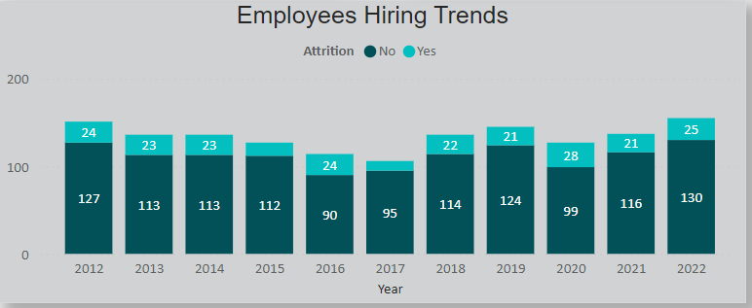

Overall, the data indicates that the attrition rate did not correlate strongly with the number of new hires. The number of employees leaving the company fluctuated within a narrow range of 21 to 25 for most of the observed period, suggesting consistent turnover independent of hiring trends.

## Active Employees by Department

Atlas Lab is composed of three main departments: Technology, Sales, and Human Resources. The majority of the company’s workforce is concentrated in the Technology department, which accounts for 67% of all employees. This allocation aligns with the company's strategy of focusing on the development and delivery of IT services and products. The Sales department follows with 29% of the workforce, supporting the company’s strong emphasis on expanding market reach and revenue generation.

In contrast, the Human Resources department maintains a significantly smaller share, with only a minimal structure needed to manage core HR functions. While this lean approach aligns with cost-efficiency, it may not be ideal for effectively supporting and managing the company's entire workforce. This limitation could contribute to the stable yet persistent attrition rate, as an understaffed HR department might struggle with addressing employee concerns, implementing robust retention programs, and providing adequate support for employee development and satisfaction

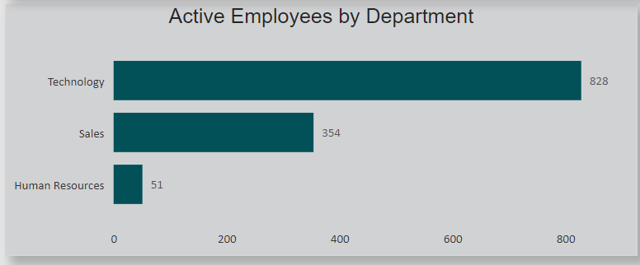

## Active Employees by Department and Job Role

Most of the active employees in the Sales department are formed by Sales Executive, while in the Technology there is a high number of Software Engineer and Data Scientists.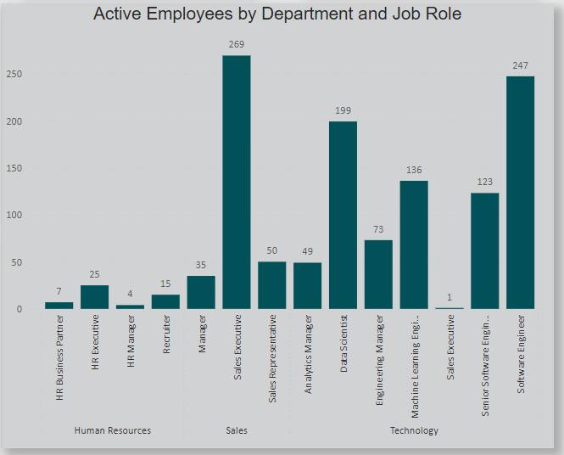

Demographics

This section will explore the personal characteristics of Atlas Lab employees, focusing on key demographics such as age and ethnicity. The goal is to gain insights into the diverse makeup of the workforce and understand the foundation that shapes the company's culture and operational dynamics. By examining these characteristics, we aim to identify patterns or trends that may influence employee engagement, satisfaction, and inclusivity within the organization. This demographic overview serves as a basis for developing initiatives that support a balanced, diverse, and inclusive workplace at Atlas Lab.

## Age Range

The youngest employee at Atlas Lab is 18 years old, while the oldest is 51. However, the average age is 29, showing that most of areas are formed by a young workforce. This is even more evident by looking at the graph below, containing the employee’s age by bins of ten years.

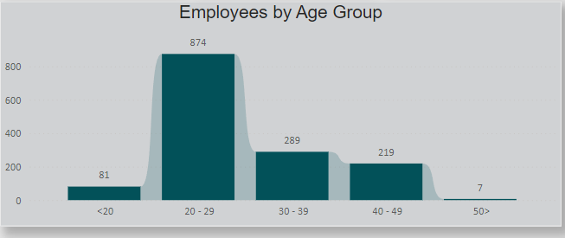

The majority of the Atlas Lab workforce falls within the 20–29 age range, highlighting a young and dynamic core of employees. This age group likely brings fresh perspectives and adaptability, contributing to a vibrant workplace culture. Additionally, a significant number of employees are under 20, suggesting that Atlas Lab may serve as a gateway for young professionals embarking on their first work experience.

At the same time, a substantial portion of the workforce is between the ages of 30 and 49, indicating a solid presence of more experienced employees. This diverse age range reflects a balance of youthful energy and seasoned expertise, creating a workforce composition that can foster innovation while also relying on the stability and insights of experienced professionals. This age distribution supports a multi-generational approach, enabling Atlas Lab to leverage a wide array of skills and perspectives.

## Marital Status

The majority of employees at Atlas Lab are married (42.45%), which suggests a stable segment of the workforce potentially rooted in family-oriented commitments. However, a notable portion of the workforce (37.35%) is single, a figure that aligns with the younger demographic within the company. This reflects the company’s appeal to early-career professionals who may prioritize career development and new experiences. Additionally, a smaller segment (20.2%) of employees is divorced, contributing further to the diversity in life stages represented within the company.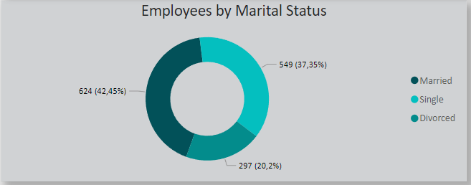

## Gender Identity by Age Group

There is a very close distribution of women and men across all age groups within Atlas Lab, reflecting the company’s commitment to fostering an inclusive gender culture. This balanced representation underscores Atlas Lab's dedication to gender equity across the workforce. Notably, there is also an expressive presence of non-binary employees, not only among younger age groups but extending into the 30–39 and 40–49 age ranges.

This diversity highlights Atlas Lab’s efforts to create an inclusive environment that welcomes individuals across the gender spectrum at various career stages. The presence of non-binary employees across multiple age brackets demonstrates the company’s commitment to supporting gender diversity and inclusivity beyond entry-level positions, establishing a culture where all employees feel valued and supported.

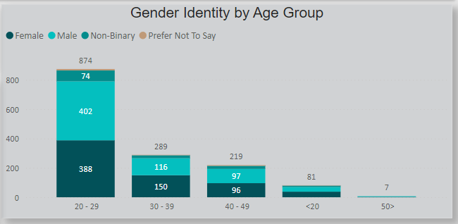

## Ethnicity Distribution and Average Salary

Atlas Lab’s workforce is composed primarily of white employees, who also receive the highest average salary within the company. Black or African American employees represent the second-largest group and receive the second-highest average salary, followed by other mixed racial and ethnic groups. This distribution suggests that while Atlas Lab has made strides in diversity, there is still progress to be made in fostering a more inclusive and representative workforce.

Currently, white employees not only make up the majority but also tend to occupy higher-paying roles, indicating a concentration of influence and seniority within this demographic. An exception to this trend is the Native Hawaiian group, which, despite being a smaller representation, holds an average salary comparable to that of white employees. This snapshot of racial and salary composition underscores the need for ongoing efforts to ensure equitable opportunities for advancement and compensation across all groups, supporting Atlas Lab’s commitment to a more diverse and inclusive workplace.

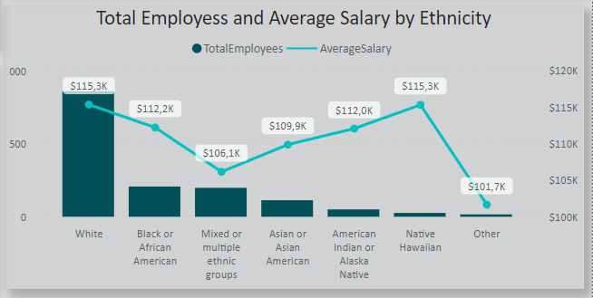

Attrition

This section will explore key aspects of employee attrition at Atlas Labs, focusing on factors such as tenure, overtime requirements, hire dates, travel frequency, and departmental distribution. The goal is to identify patterns and trends that may contribute to turnover within the organization. By examining these elements, we aim to uncover insights that can inform retention strategies, improve workforce stability, and optimize departmental support for employees. This analysis serves as a foundation for developing targeted initiatives that address the specific needs of Atlas Labs' diverse workforce, fostering a more engaged and sustainable employee base.

## Overtime Requirement and Ternure

The *Overtime Requirement* graph reveals that employees required to work beyond their expected hours are significantly more likely to leave the company. In fact, nearly 75% of those who exited Atlas Lab had overtime requirements. This trend points to a potential issue of understaffing, especially given the reduction in new hires over recent years. Additionally, this pattern could indicate a lack of investment in productivity-enhancing technologies or workflow optimization, potentially resulting in employees shouldering heavier workloads. Addressing these factors may be crucial for improving retention, as reducing overtime demands could alleviate burnout and enhance job satisfaction.

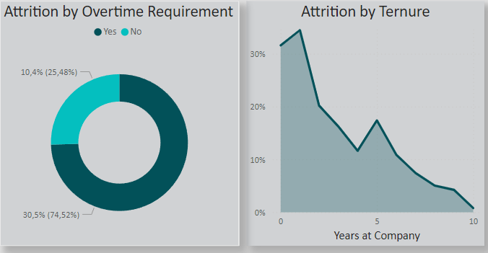

As anticipated, the *Tenure* graph highlights a clear negative correlation between years of service and employee attrition rates. As the years at the company increase, the likelihood of attrition reduces. Notably, there is an exceptionally high attrition rate among employees in their first year, which drops significantly after they complete 2–4 years at Atlas Lab. This trend suggests potential challenges in adapting to the company’s demands, particularly for new employees who may be required to work overtime.

To address this, Atlas Lab must consider implementing a supportive workforce policy focused on first-year employees. Providing tailored support, resources, and engagement strategies for newcomers can help them better adapt to their roles, enhance job satisfaction, and reduce early-stage attrition. Ensuring that new employees feel equipped and valued during their initial period could be vital in building a more stable and committed workforce.

## Attrition % by Department and Role

An analysis of attrition rates by department reveals that four roles have a higher-than-average attrition percentage: **Recruiter** in HR (37.5%), **Sales Executive** (17.5%) and **Sales Representative** (39.8%) in Sales, and **Data Scientist** in IT (23.8%). The **Sales department** has the highest overall percentage of employees leaving, indicating potential challenges in addressing the issues faced by this group. Similarly, the high attrition rate for the **Recruiter** role in HR highlights a significant concern within the department that warrants immediate attention.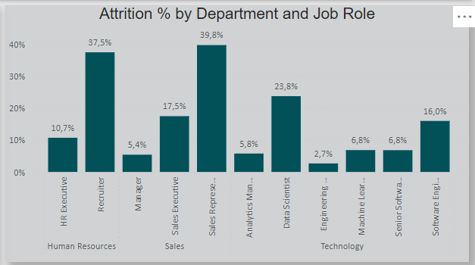

## Attrition % by Travel Frequency

Employee travel frequency shows a significant relationship with attrition rates: employees who travel frequently are far more likely to leave the company compared to those who travel occasionally or not at all. This trend aligns with the high attrition rate observed among **Sales Representatives**, suggesting that frequent travel, a key aspect of their role, may be a contributing factor. This indicates a potential gap in the support provided to these employees, which should be addressed to improve retention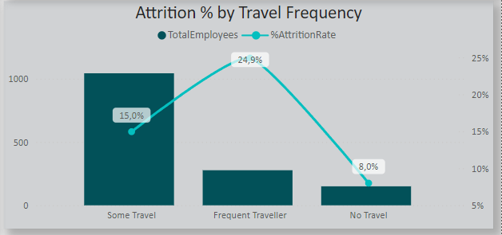

# Conclusion

The comprehensive analysis of Atlas Lab’s workforce provides valuable insights into its demographic composition, operational dynamics, and attrition trends. While the company demonstrates strengths such as a young, dynamic workforce, balanced gender representation, and efforts toward diversity, several critical areas require attention to foster a more stable and engaged employee base.

Attrition emerges as a significant challenge, particularly in the **Sales** and **HR** departments, with roles such as **Sales Representatives** and **Recruiters** experiencing notably high turnover. Factors such as **overtime requirements** and **frequent travel** contribute to these attrition rates, suggesting the need for targeted interventions. For instance, reducing overtime demands, offering travel support, and addressing specific challenges in these roles can improve employee retention and satisfaction.

Furthermore, the high attrition rates among first-year employees point to onboarding and early-stage adaptation challenges. Oriented support programs for new hires, such as mentorship, structured training, and workload management, could mitigate these issues and improve workforce stability.

Demographically, Atlas Lab benefits from a diverse age range and gender inclusivity but shows disparities in **ethnicity representation and salary distribution**. While white employees dominate higher-paying roles, investing in equitable career progression and compensation opportunities for underrepresented groups should be a priority to strengthen inclusion and fairness across the organization.

To sum up, in order to address these findings, Atlas Lab should consider:

1. **Retention Strategies**: Develop targeted retention plans for high-attrition roles, focusing on workload management, travel policies, and employee support.
2. **Onboarding Initiatives**: Implement robust first-year programs to aid employee adaptation and reduce early-stage turnover.
3. **Diversity and Inclusion Efforts**: Promote equitable opportunities in leadership and compensation to enhance workforce representation and morale.
4. **HR Expansion**: Reassess the structure and capacity of the HR department to effectively manage the growing and diverse workforce.

By following these strategies, Atlas Lab can create a more inclusive, supportive, and performance-driven workplace, ensuring its workforce remains a cornerstone of its long-term success.